**The Emergency Response Plans – Flip Chart TP.HSW 01.30**

This document details the Emergency Response Plans Flip Chart and its contents.

The Flip Chart has been purpose made to centralise as much info as possible that is required for use in the event of a Hazardous Substance type of emergency.

It contains layout diagrams, emergency contact lists, information on emergency response and first aid procedures for the Hazardous Substances that would be found at a Transpower site.

There should be an Emergency Response Plans Flip Chart on every Transpower site.

The following are the pages that should be inserted into the clear plastic sleeves in the flip chart. There are thirteen clear sleeves and there should be something in each one. Please note, sleeve 14 does not need printing.

They are: -

Front Cover – as pictured at right

Inside of Cover – Emergency Call – as pictured at right

Sleeve 1. Emergency Contact List

Sleeve 2. Hazardous Substances Site Layout Plan

Sleeve 3. Fire Equipment Site Layout Plan

Sleeve 4. First Aid – Patient Not Responding

Sleeve 5. First Aid – Patient Responding

Sleeve 6. Correct Use of Fire Extinguisher

Sleeve 7. Transformer & Lubricating Oils

Sleeve 8. Gasses – Flammable or Oxidising

Sleeve 9. Gasses – Non-Flammable

Sleeve 10. Solvents

Sleeve 11. Corrosives

Sleeve 12. Environmentally Sensitive Areas

Sleeve 13. Safety Data Sheets

Sleeve 14. Document Information (does not need to be printed)

# TP.HSW 01.30

# Emergency Response Plans Flipchart

Site: Arthurs Pass (APS)

|  |  |
| --- | --- |
| Document Number | TP.HSW 01.30 |
| Issue Number | 1.2 |
| Publication Date | May 2025 |
| Document Status | Approved |

Inserts:

Emergency Call First Aid (responding) Solvents

Emergency Contact List Correct Use of Fire Extinguisher Corrosives

Hazardous Substances Site Plan Transformers & Lubricating Oils Environmentally Sensitive Areas

Fire Equipment Plan Gasses: Flammable or Oxidising Safety Data Sheets

First Aid (not responding) Gasses: Non-flammable Document Information (does not need to be printed)

**Incident occurs at location**

**EMERGENCY CALL**

**Call EMERGENCY SERVICES then the PERSON IN CHARGE or (if the ‘Person in Charge’ is not on site) THE MOST SENIOR PERSON ON SITE. Give a brief description of:**

* **What happened, when and where?**
* **The number of injured persons?**
* **What kind of injuries have they received?**
* **Are there any site specific issues, e.g. public safety?**
* **Is there any risk to nearby neighbours or the environment, e.g. streams, rivers, stormwater system, etc?**

Call Emergency Services

Contact Person in Charge

(Refer Emergency Contact List)

Person in Charge contacts Approved Handler for location (if not already advised)

Person in Charge or Approved Handler for site liaises with Emergency Services and NGOC. Emergency Services not allowed on site unsupervised.

Incident Involving Hazardous Substances

- Corrosives - Gases (Flammable/Non-Flammable)

- Solvents - Oils

Contact Approved Handler for details. Refer appropriate response sheet in this flipchart and Material Safety Data Sheet folder for additional assistance

Environmental Issues

* Refer “Environmentally Sensitive Areas”
* Consider need to contact Regional Council Pollution Hotline

Person in Charge advises all affected parties when the incident has been resolved

Location Name: Arthurs Pass (APS) Phone Number: (03) 318 9207

Street Address: State Highway 73, Arthurs Pass Rapid Number: N/A

GPS Location: S 42 º 56.649 ' E 171 º 34.057 '

Date Updated: _______________________________________________ Updated by whom: _________________________________________

**Emergency Contact List**

|  |  |
| --- | --- |
| **Service** | **Contact Number** |
| Any Site Emergency | National Grid Operating Centre (NGOC) - Auckland: 09 274 8736  National Coordination Centre (NCC) - Wellington: 04 563 5087  National Grid Operating Centre (NGOC) - Christchurch: 03 349 7043 |
| Emergency Services (Fire/Ambulance/Police) | Phone Number: 111 |
| Person in charge of this location (if applicable)  This person has overall responsibility for site safety and HSNO compliance | Name: James Brewer  Mobile Phone Number: 027 263 7941 |
| Site Specific Issues | Regional Service Managers (RSMs):  RSC1 and RSC2 (North-North Island) – Archana Devi: 09 589 2300, 021 482 254  RSC3 and RSC4 (South-North Island) – Brendan Olsen: 06 357 0919, 021 424 712  RSC5 and RSC6 (South Island) – Blair Upton: 03 365 6948, 021 390 614 |
| All general queries | Phone: 0800 THE GRID (0800 843 4743) |
| National Poison Centre (Emergency Only)  Chemical Hotline (specialist chemical advice) | Phone: 0800 764 766  Phone: 0800 243 622 |
| Regional Council Pollution Hotline | Phone: 0800 765 588 |
| WorkSafe NZ | Phone: 0800 030 040 |
| Immediate Neighbour Address: | Neighbour or Landowner Liaison Phone: |
| Immediate Neighbour Address: | Neighbour or Landowner Liaison Phone: |
| Immediate Neighbour Address: | Neighbour or Landowner Liaison Phone: |

Sleeve One – Emergency Contact List

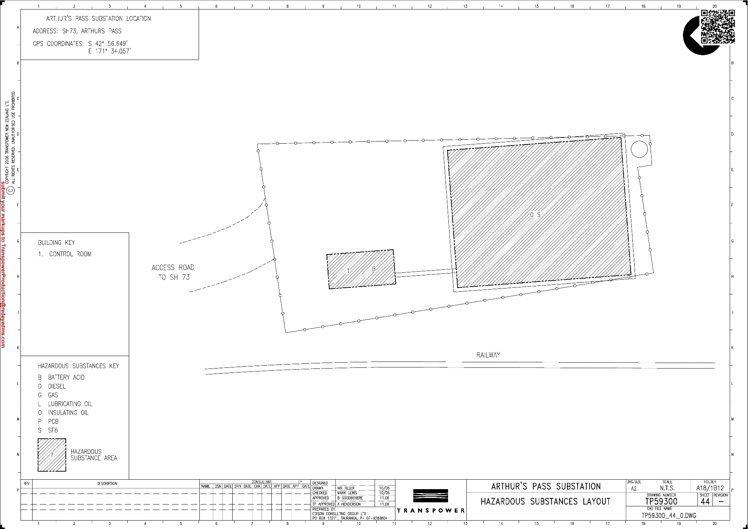

**Hazardous Substances Site Plan**

Sleeve Two – Hazardous Substances Site Plan

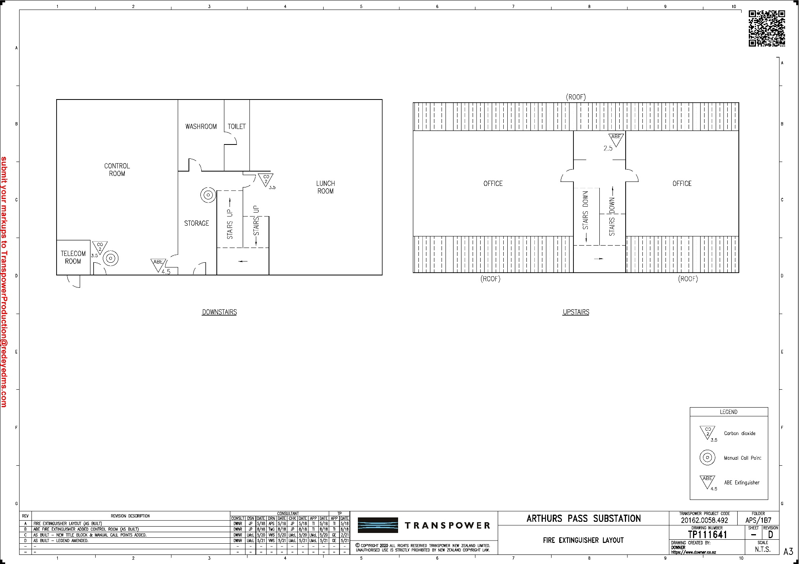

**Fire Equipment Plan**

Sleeve Three – Fire Equipment Plan

First aid is as easy as ABCD – airway, breathing, CPR (cardiopulmonary resuscitation) and defibrillation.

**First Aid – Patient Not Responding**

In any relevant situation, apply the DRSABCD Action Plan.

The information below is also available on the free St John App, available on IOS, Android and Google.

Sleeve Four – First Aid Patient Not Responding

**Look for normal breathing.**

**Follow the instructions on your AED.**

**Place hands in the centre of the chest. Push down hard 30 times and then give 2 breaths.**

**Continue cycles of 30 compressions and 2 breaths.**

**Move the head into a neutral position and lift the chin.**

**Call 111 and ask for an ambulance.**

**Ensure yourself and others are safe.**

**Check for response:** “*Can you hear me?”*

**If possible, move the patient to a stable, flat surface such as the floor.**

**First Aid – Patient Responding**

**What to do if someone is bleeding:**



4. Treat for shock

3. Secure dressing with a bandage to maintain pressure

1. Press itA picture containing clipart

   Description automatically generated

**What to do if someone is in shock:**

2. Call 111 for emergency help

3. Loosen any tight clothing

4. Keep them comfortable and warm

5. Monitor their level of response, if they become unresponsive prepare to give CPR

1. Lie them down

Their legs should be raised & supported

Sleeve Five – First Aid Patient Responding

**Signs and symptoms**

Look for:

* intense pain in the eye
* inability to open the injured eye
* redness and swelling around the eye
* a significant amount of watering of the eye
* chemical substances near the casualty.

**What to do**

1. Put on protective gloves if they’re available. Hold the casualty’s eye under gently running water for at least 20 minutes and make sure the outside and inside of the eyelid is washed.
   * If the casualty’s eye is shut due to pain, gently but firmly open it so it can be washed out.
2. Make sure the contaminated water does not splash the uninjured eye, you, or the casualty.

If the casualty is wearing contact lenses, ask them to remove them if they can.

1. Ask the casualty to hold a clean non-fluffy pad over the injured eye and bandage in place.
2. Call 111. If you know what chemicals might have been involved in the accident, pass this information on to the medical professionals.

**Chemical burn to the eye:**

**Correct Use of Fire Extinguisher**

**1. Identify a clear exit/escape route**

Before operating the fire extinguisher, make sure you have a clear evacuation path. If you cannot put out the fire, you’ll need to make a safe exit. Consider this when determining where to store your fire extinguisher, and make sure you’ll have multiple exit options nearby after you retrieve it.

**2. Stand back**

Face the fire and keep your back to the clear exit you earlier identified. You should stay between six and eight feet away from the flames as you prepare to operate the fire extinguisher.

**3. Discharge extinguisher**

It can be difficult to think clearly during an emergency, so fire safety has a long-standing acronym to help you recall the steps involved in operating your fire extinguisher.

When extinguishing a fire, you should **PASS**:

**P: Pull** the pin on the fire extinguisher.

**A: Aim**the extinguisher nozzle on the hose low, toward the base of the fire.

**S: Squeeze** the handle or lever to discharge the extinguisher.

**S: Sweep** the nozzle back and forth. Keep the fire extinguisher aimed at the base of the fire and move it from side to side until the flames are extinguished.

* **Put used extinguishers away until they have been refilled**
* **Call to arrange replacement/refill of used extinguishers**

1. Pull the pin at the top to break the tamper seal.

2. Aim the extinguisher low, pointing the nozzle at the base of the fire. Do not aim at the flames themselves.

3. Squeeze the handle to release the extinguishing agent.

Sleeve Six – Correct Use of a Fire Extinguisher

Sleeve Seven – Transformer and Lubricating Oils



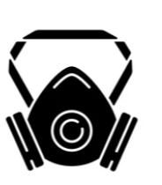

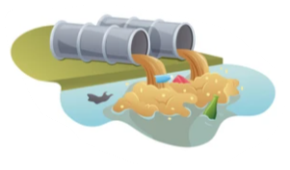

|  |  |  |  |
| --- | --- | --- | --- |
| **Hazards** | **Comment** | **Precautions** | **Comment** |
|  | Frequent skin contact removes natural protective fats from the skin.  Dermatitis and other skin problems can result. |  | Wear protective gloves, barrier creams, and safety boots when necessary.  Wash or discard oil-soaked boots and clothing. Keep oily rags out of pockets. |
|  | Inhaled oil mist can damage lungs |  | Use a filter mask in oil mist conditions. |
|  | Oil spills can seep into waterways and cause long term pollution. |  | Soak up oil spills with diatomaceous earth or other absorbent. Dispose of oily waste using an approved disposal company or depot.  Never pour oil down drains or sewers. |
|  | Oil is extremely slippery on floors, ladders, handrails, steps, and catwalks. |  | Keep oily gloves and boots off ladders, handrails, steps, and catwalks. |
|  | Oil spills, oily rags and oily clothing when heated are combustible. |  | Fight oil fires with CO2 or dry powder fire extinguishers. In confined spaces, fire fighters must wear self-contained breathing apparatus. |

**Transformer & Lubricating Oils**



**Gases Flammable or Oxidising** **(e.g., Acetylene, Oxygen)**

|  |  |  |  |
| --- | --- | --- | --- |
| **Hazards** | **Comment** | **Precautions** | **Comment** |
|  | **Acetylene (C2H2), LPG (Propane)**  Highly flammable gas producing acrid smoke and irritating fumes. Product will add fuel to a fire.  In event of a cylinder catching fire, keep the cylinder (and those in the immediate area) cool by applying water from a protected location. If safe to do so, stop gas flow by closing cylinder valve. If gas valve cannot be turned off, DO NOT extinguish the flame, since re-ignition or explosion could occur. |  | In the event of a gas leak, **eliminate all sources of ignition** e.g., naked flames, cell phones electrical equipment etc.  At the onset of dizziness or eye, nose, and throat irritation, IMMEDIATELY vacate the area and move to an area where there is fresh air.  Warn others of the danger of low oxygen and alert site management.  Do not rush into an enclosed space to help a collapsed workmate. Call for help first. If the oxygen level is below 19%, organise breathing equipment, lifeline, and standby helpers before entering. |
|  | Acetylene is an asphyxiant gas which may displace the air. |  | Before re-entering the work area use an explosimeter or gas detector to confirm that the atmosphere is safe. DO NOT enter a space where the oxygen level is below 19% (potential asphyxiation) or above 21% (higher risk of fire). |
|  | **Oxygen (O2)**  While being a non-toxic, non-flammable gas, it is a very strong oxidising agent. Oil/grease can spontaneously ignite at low temperatures in an oxygen enriched environment. Materials that would not burn in air will burn vigorously in pure oxygen. |
|  | **Gases – General**  Rapidly expanding gases cool the surrounding area, which could result in severe cold burns. |  | Wear thick, insulating gloves and eye protection when handling pipework or containers holding compressed gases. |
|  | Full gas cylinders store products at high pressure. Poor storage or handling of cylinders can result in cylinder rupture or the catastrophic release of product.  Do not store near ignition sources, heat sources, oxidising agents, or flammable solvents.  Store in well ventilated area. |  | Cylinders should be secured in an upright position and away from heat sources.  Cylinders that are not in use should have their protective caps in place. |

Sleeve Eight – Flammable or Oxidising Gases

Sleeve Nine – Non-flammable gases

|  |  |  |  |
| --- | --- | --- | --- |
| Hazards | **Comment** | **Precautions** | **Comment** |
|  | **Nitrogen (N2) and Carbon Dioxide (CO2)**  Both gases are colourless and odourless. They can displace air and accumulate in poorly ventilated enclosed places. Inhalation of concentrated nitrogen or carbon dioxide causes immediate unconsciousness, followed by death.  Gas cylinders, pipes and valves that contain nitrogen or carbon dioxide can rapidly become extremely cold, which can result in severe cold burns. |  | At the onset of dizziness or eye, nose, and throat irritation, IMMEDIATELY vacate the area and move to an area where there is fresh air.  Warn others of the danger of low oxygen and alert site management. |
|  | **Sulphur Hexafluoride (SF6)**  Sulphur hexafluoride is used chiefly as an insulating medium for a wide range of high voltage electrical and electronic equipment. As a gas it is significantly heavier than air and will accumulate in low lying areas of poorly ventilated enclosed places.  Gas cylinders, pipes and valves that contain SF6 can rapidly become extremely cold, which can result in severe cold burns. |  | Before re-entering the work area use an explosimeter or gas detector to confirm that the atmosphere is safe. DO NOT enter a space where the oxygen level is below 19%.  **Do not rush into an enclosed space to help a collapsed workmate**. Call for help first. If the oxygen level is below 19%, organise breathing equipment, lifeline, and standby helpers before entering. |
|  | **Gases – General**  Rapidly expanding gases cool the surrounding area, which could result in severe cold burns. |  | If trained and qualified to work with pipework, ear thick, insulating gloves and eye protection when handling pipework or containers holding compressed gases. |
|  | Full gas cylinders store products at high pressure. Poor storage or handling of cylinders can result in cylinder rupture or the catastrophic release of product. |  | Cylinders should be secured in an upright position and away from heat sources.  Cylinders that are not in use should have their protective caps in place. |

**Gases, Non-Flammable** **(e.g. SF6)**

|  |  |  |  |
| --- | --- | --- | --- |
| Hazards | Comment | Precautions | Comment  **Solvents (Paint thinners, Toluene, Xylene, MEK)** |
|  | Frequent skin contact removes natural protective fats from the skin. Dermatitis and other skin problems can result. |  | Wear protective gloves, barrier creams, and safety boots when necessary.  Wash or discard boots and clothing contaminated with solvent. Keep solvent contaminated rags out of pockets. |
|  | Inhaled solvent mist and vapours can damage the lungs and lead to poisoning, unconsciousness, and death. |  | Use a filter mask in solvent vapour conditions. Stand upwind when handling solvents. |
|  | Spillages can seep into waterways and cause long term pollution.  Spillages can also spread the risk of fire. |  | Soak up spills with diatomaceous earth or other absorbent. Stand upwind when handling solvents. Dispose of waste using an approved disposal company or depot. Store waste materials away from ignition sources.  Never pour solvents down drains or sewers. |
|  | Some solvents are poisonous if swallowed, inhaled, or absorbed through the skin.  Eye contact can be extremely painful (refer First Aid – Responding: Chemical in Eye). | Personal Protective Equipment: What Sanctions are what they are for | Wear the appropriate personal protective equipment (gloves, barrier cream, boots, and apron where necessary). Use a filter mask rated for solvents to prevent inhalation of product mist or vapour.  Do not eat food in areas containing solvents and always wash your hands after handling solvents. |
|  | Some solvents are highly flammable and can ignite explosively when mixed with air. |  | Store solvents away from any other chemicals (particularly oxidising agents).  Fight solvent fires with CO2 or dry powder fire extinguishers. In confined spaces, fire fighters must wear self-contained breathing apparatus. |

Sleeve Ten - Solvents

Sleeve Eleven - Corrosives

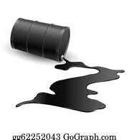

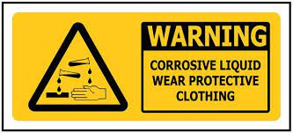

Wind direction



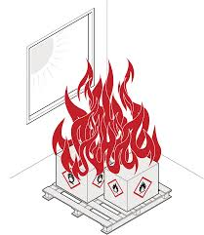



**Corrosives**

|  |  |  |  |
| --- | --- | --- | --- |
|  | Corrosive chemicals (acid and alkalis) are poisonous if swallowed or inhaled. Contact burns the skin, eyes, and clothing. |  | Wear protective gloves, boots, and a full facemask when handling corrosives. Use appropriate filter mask to avoid breathing fumes and chemical dust. Use breathing equipment if poisonous gas is present. |
|  | Heated containers of corrosive liquids can become pressurized and burst, spraying the contents. |  | Keep containers of corrosives out of the sun and away from hot machinery and pipe work. |
|  | Corrosives spills can release hazardous fumes and when mixed with products or with other chemicals can cause fires or contact with metals may release flammable gases that could result in an explosion or produce poisonous gases. |  | Wear full personal protective equipment when responding to spill. Stop flow of material and contain/absorb small spills with dry sand, earth or approved absorbent material – avoid product contact with metals and combustible materials. Always stand up-wind of the spill & open doors & windows. Do not disperse spill with water (unless instructed by Emergency Services). In the event of a fire, move containers from the immediate area if you can do so without risk.  Do not store or transport corrosive chemicals with incompatible products or materials. If in doubt, contact the Transpower Health, Safety and Wellbeing team. |
|  | Corrosive chemicals can react violently when water is added. |  | Add corrosive chemicals to water slowly, whilst stirring. Do not pour water directly into corrosive chemicals. Never use hot water. Ensure container can withstand the heat of reaction and will not collapse. |
|  | Check that container caps are screwed on tight before lifting and carrying. Unscrew caps slowly, keeping your face away from the opening to release the internal pressure. |

Sleeve Twelve – Environmentally Sensitive Areas

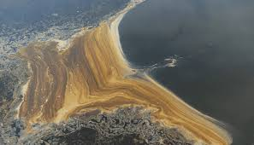

**Environmentally Sensitive Areas**

|  |
| --- |
|  |
|  |
|  |
|  |
|  |
|  |
|  |
|  |
|  |
|  |
|  |
|  |
|  |

List any of the following: include name, approximate distance from the site and direction. Include areas within a 500-metre radius of the site.

River, stream, underground well, stormwater drain, channel, reservoir, underpass, tunnel, underground railway line, other underground facility, railway, school, public buildings, residential zone etc., in near vicinity.

e.g., Primary School, 500 metres North

Remember that oils & solvents (hydrocarbons) float on water, so a board can be used for product containment while letting clear water pass underneath

Do not let any oils or solvents enter the sewer / stormwater system. Use any available material to construct a barrier.

Try to prevent untrained fire department personnel from flushing product spills into adjacent sewers or stormwater. Explain the dangers of this action

**Waterways**

**Spill Containment Techniques**

Many sites are equipped with ‘Oil Separators’. In the event of a spill, ensure that (where fitted) the outlet valve for the separator is closed. To be effective, these separators must be regularly maintained and after a spill, emptied and cleaned by an approved waste disposal company.

In cases where there is no site oil separator or a spill is moving towards a sewer or stormwater, the following are some examples of containment methods that may be used in case of an emergency. Use absorbent materials (sawdust, straw, diatomaceous earth) to soak up the spill.

**Drains & Sewers**

**Safety Data Sheets**

All Safety Data Sheets (SDS’s) are available in the Site Information Folder, located by the sign in area.

The most recent versions of SDS’s can be accessed electronically from the ‘secure area’ on Transpower’s Internet Site ([www.transpower.co.nz](http://www.transpower.co.nz)). They are stored on the Hazardous Materials and Substances page.

In the event of an emergency, Safety Data information can also be obtained from the National Poisons Centre or phone: 0800 POISON (0800 764 766)

Sleeve Thirteen – Safety Data Sheets

## Document Information

|  |  |
| --- | --- |
| Document Number | TP.HSW 01.30 |
| Issue Number | 1.1 |
| Publication Date | May 2025 |
| Document Status | Approved |

## 1.1 Summary of Changes

| Document History | | | |
| --- | --- | --- | --- |
| Issue No. | Affected Section | Change | Date |
| 1 | Whole document | Publication of document | January 2023 |
| 1.1 | Emergency Contact sheet & footers | Regional Services Manager details updated for RSC1 and RSC2 (Auckland, Waikato and Bay of Plenty) and names of each section added to the footer of each page | May 2025 |
| 1.2 |  | Minor changes due to Service Provider feedback. | May 2025 |

## 1.2 Document Contact

This document is the responsibility of Transpower New Zealand Limited, Wellington. If you have any queries please contact [controlled_docs@transpower.co.nz](mailto:controlled_docs@transpower.co.nz).

## 1.3 Use of this Transpower Controlled Document

1. The information in this document belongs to Transpower and may only be used by Transpower, and parties contracted by Transpower to undertake work on or in respect of Transpower’s assets, for the purpose described on page 1.
2. Engineering consultants/Service providers contracted by Transpower which use/rely on the information in this document must apply good engineering practice and their own professional judgement while undertaking any works contemplated by or relevant to the use of such information.
3. All information in this document is confidential and users must take reasonable precautions against unauthorised use or disclosure of such information.

## 1.4 Document Feedback

If you would like to submit any feedback or suggestions to Transpower to improve this document, use one of the following options:

* Email [controlled_docs@transpower.co.nz](mailto:controlled_docs@transpower.co.nz)
* From the Contractors / Consultants section on the [Transpower website](https://aus01.safelinks.protection.outlook.com/?url=http%3A%2F%2Fwww.transpower.co.nz%2F&data=05%7C01%7CJaimie.Olsen%40transpower.co.nz%7C32deeb7f690f40ae56b908daf98e1af1%7Ccb644580651946f6a00f5bac4352068f%7C0%7C0%7C638096685980233745%7CUnknown%7CTWFpbGZsb3d8eyJWIjoiMC4wLjAwMDAiLCJQIjoiV2luMzIiLCJBTiI6Ik1haWwiLCJXVCI6Mn0%3D%7C3000%7C%7C%7C&sdata=EshC3yRtuFq25BKeLpQJ6aJzxckNQrOYYSS%2BkmTb5Hg%3D&reserved=0), [www.transpower.co.nz](https://aus01.safelinks.protection.outlook.com/?url=http%3A%2F%2Fwww.transpower.co.nz%2F&data=05%7C01%7CJaimie.Olsen%40transpower.co.nz%7C32deeb7f690f40ae56b908daf98e1af1%7Ccb644580651946f6a00f5bac4352068f%7C0%7C0%7C638096685980233745%7CUnknown%7CTWFpbGZsb3d8eyJWIjoiMC4wLjAwMDAiLCJQIjoiV2luMzIiLCJBTiI6Ik1haWwiLCJXVCI6Mn0%3D%7C3000%7C%7C%7C&sdata=EshC3yRtuFq25BKeLpQJ6aJzxckNQrOYYSS%2BkmTb5Hg%3D&reserved=0), use the online [Controlled Document Feedback Form](https://aus01.safelinks.protection.outlook.com/?url=https%3A%2F%2Fwww.transpower.co.nz%2Fmy-transpower%2Fcontrolled-documents%2Fforms%2Fcontrolled-document-feedback-form&data=05%7C01%7CJaimie.Olsen%40transpower.co.nz%7C32deeb7f690f40ae56b908daf98e1af1%7Ccb644580651946f6a00f5bac4352068f%7C0%7C0%7C638096685980233745%7CUnknown%7CTWFpbGZsb3d8eyJWIjoiMC4wLjAwMDAiLCJQIjoiV2luMzIiLCJBTiI6Ik1haWwiLCJXVCI6Mn0%3D%7C3000%7C%7C%7C&sdata=GKvWvybCGnFCAVh7Y61KRMRhoEJI8SN6KkXxr92cOz0%3D&reserved=0)
* From within Transpower, use the [Controlled Documents Feedback Register Form](https://aus01.safelinks.protection.outlook.com/?url=https%3A%2F%2Ftranspowernz.sharepoint.com%2Fsites%2Fgm63%2F_layouts%2F15%2Flistform.aspx%3FPageType%3D8%26ListId%3D%257B514525A7-ED7B-4616-9301-EE61697E3AEB%257D%26RootFolder%3D%252Fsites%252Fgm63%252FLists%252FFeedbackRegister%26Source%3Dhttps%253A%252F%252Ftranspowernz.sharepoint.com%252Fsites%252Fgm63%252FLists%252FFeedbackRegister%252FAllItems.aspx%26ContentTypeId%3D0x0100C2310B385F64674E80FBAE41C8225082&data=05%7C01%7CJaimie.Olsen%40transpower.co.nz%7C32deeb7f690f40ae56b908daf98e1af1%7Ccb644580651946f6a00f5bac4352068f%7C0%7C0%7C638096685980233745%7CUnknown%7CTWFpbGZsb3d8eyJWIjoiMC4wLjAwMDAiLCJQIjoiV2luMzIiLCJBTiI6Ik1haWwiLCJXVCI6Mn0%3D%7C3000%7C%7C%7C&sdata=61wJxNh1PxVSBgOdIE%2Fdsi004vls4TwrVUVvlZhFwSs%3D&reserved=0).